Software Requirement Specifications

AI-Assisted Software Development Efficiency Analyzer



Submitted by
Muhammad Anas (S23BINFT1M01019)

Submitted to
Mr. Zaman Ali

Department of Information Technology
Faculty of Computing
The Islamia University of Bahawalpur

Meeting Details
Sr No | Details | Date | Supervisor Signature

Summary
This document is the Software Requirements Specification for the AI-Assisted Software Development Efficiency Analyzer. The system watches how developers use AI tools while they are making software and rates how this affects their overall efficiency, such as how quickly they code, how good their output is, and how productive they are. The system collects detailed data on how developers and AI coding assistants interact with each other. This data is then used to create useful insights and performance metrics that encourage developers to use AI in their work in a more responsible and effective way.
The tech stack for this system includes React on the frontend, Laravel as the backend framework, MySQL for storing data, and the OpenAI API to power the built-in AI assistant. This document covers the full set of requirements, use cases with activity diagrams, and the overall architecture of the system.

Table of Contents
1. Introduction 5
1.1. Purpose 5
1.2. Scope 5
1.3. Product Perspective 6
1.4. User Characteristics 6
1.5. Similar Apps and Systems / Literature Review 6
1.6. Proposed Technologies 7
2. Requirements 9
2.1. Functional Requirements 9
2.2. Non-Functional Requirements 14
3. Use Cases and Flow of Processes 15
3.1. Use Case 1 — Developer Registration and Login 16
3.2. Use Case 2 — Assign Coding Task 19
3.3. Use Case 3 — Conduct AI-Assisted Coding Session 21
3.4. Use Case 4 — Analyse Session and Compute Performance Metrics 24
3.5. Use Case 5 — View Performance Metrics Dashboard 26
3.6. Use Case 6 — Receive Insights and Recommendations 28
3.7. Use Case 7 — Receive Adaptive AI Assistance 30
3.8. Use Case 8 — Track Skill Development 32
3.9. Use Case 9 — Manage System Administration Panel 34
4. References 36

Introduction

These days, AI tools like GitHub Copilot and ChatGPT are used by almost every developer. They save time and make certain tasks easier, which is why so many people have started relying on them. But there is a real question that nobody is properly answering yet: are developers actually using these tools the right way, and what effect do they have on the quality of work being produced?
This project, the AI-Assisted Software Development Efficiency Analyzer, is built to answer that question. It is a web application that sits alongside a developer while they work, records how they use the AI assistant, and then shows them data about their own performance. The goal is not to judge developers but to help them understand where they are doing well and where they might want to improve. This system would mainly be useful for individual developers, team managers, university students learning to code, and researchers studying how AI is changing the way software is built.

Purpose

The purpose of this SRS document is to lay out everything the AI-Assisted Software Development Efficiency Analyzer is supposed to do. Writing this document helps make sure that everyone involved in the project, whether that is the developer, the supervisor, or anyone reviewing it later, understands what is being built and why. The main things this document covers are:
- Building a system that records how developers use AI tools while they are coding.
- Measuring the effect of that AI usage on how fast they work, how productive they are, and how good their code is.
- Giving developers useful feedback and metrics so they can improve the way they use AI.
- Listing all the functional requirements that describe what the system needs to do.
- Listing all the non-functional requirements that describe how well the system needs to do it.
- Providing use case descriptions and activity diagrams for each major part of the system.

One reason this kind of tool matters especially in an academic setting is that professors and instructors are increasingly concerned about how students use AI tools when completing assignments. This system could help shed some light on that.

Scope

The AI-Assisted Software Development Efficiency Analyzer is a browser-based web application. Below are the things it will include:
A coding workspace that runs in the browser, uses the Monaco code editor, and has an AI assistant panel connected to the OpenAI API.
- A tracking system that logs everything the developer does during a session — AI prompts sent, code edits made, times the code was run, and any errors that came up.
- An analytics engine that takes all those logs and turns them into numbers — how fast they worked, how correct the code was, and how clean the code quality was.
- A dashboard where developers can look at all their stats in the form of charts and graphs.
- A recommendation engine that looks at the session data and gives the developer a few tips about what to do better next time.
- Different access levels for Developers, Team Leads, and System Administrators.

Some things will not be part of this version of the system:
- Connecting to GitHub, GitLab, or any other version control system.
- Running on phones or tablets.
- Hosting on a cloud server or enterprise infrastructure.

Product Perspective

This system is not part of any existing platform. It is a standalone web application. On the inside, it is split into four parts that all work together: the React frontend that the developer sees and uses, the Laravel backend that handles all the logic and data processing, the MySQL database that stores everything, and the OpenAI API that powers the AI assistant.
One design decision that was made early on is that the analytics part of the system should not depend too much on which AI provider is being used. That way, if the OpenAI API ever needs to be swapped out for something else in the future, the rest of the system would not need to be completely rebuilt.

User Characteristics

Three types of users will be interacting with this system:

User Role | Technical Level | Primary Interaction with the System
Developer | Intermediate to Advanced | Uses the coding workspace, works with the AI assistant, and checks their own performance stats and recommendations.
Team Lead / Supervisor | Advanced | Looks at team-level productivity data, compares how different developers are using AI, and reviews code quality trends.
System Administrator | Advanced (IT Background) | Handles user accounts, sets up coding tasks, manages system settings, and keeps an eye on platform health.

All three user types will just need a modern web browser to use the system. There is no software to install.

Similar Apps and Systems / Literature Review

A few existing tools and research studies are related to what this project is trying to do. The table below compares them and explains what gap this system fills.

System / Study | Key Feature | Shortcoming Addressed by This Project
GitHub Copilot | AI code suggestion inside editors | It gives suggestions but has no way of telling whether those suggestions are actually improving the developer's work or making things worse.
CodeClimate | Checks code quality after a commit | Runs quality checks after the fact, not during coding, and does not track developer-AI interaction.
LeetCode / HackerRank | Coding challenges with auto grading | Good for testing raw coding skill but does not involve any AI assistant or measure how a developer uses one.
Ziegler et al. (2022) | Research on Copilot and productivity | Looks at how often suggestions are accepted but does not track code quality going down over time or growing AI dependence.

Proposed Technologies

These are the technologies that will be used to build this system:

Layer | Technology | Role in the System
Frontend | React.js, Tailwind CSS, Monaco Editor, Chart.js | Builds the coding workspace and dashboard UI. Tailwind handles styling, Monaco is the code editor, and Chart.js draws the analytics graphs.
Backend | Laravel (PHP), Laravel Sanctum | Laravel runs the API and business logic. Sanctum handles token-based authentication between frontend and backend.
AI Integration | OpenAI API (GPT-4o) | Runs the AI assistant panel that gives code suggestions and debugging help.
Database | MySQL | Stores all user data, session logs, task details, and computed metric results.

Requirements

The core purpose of this system is to watch how developers interact with AI tools during a coding task and then measure what effect that had on their speed, output, and code quality. The way it works in practice is: a developer logs in, gets assigned a task, opens the coding workspace, and starts writing code. The AI assistant is right there on the side if they want to use it. While all this is happening, the system is quietly recording every prompt they send, every edit they make, every time they run the code, and every error that appears. Once they submit their solution, all of that data goes to the analytics engine which produces a full picture of how the session went.
In practice, different developers use AI tools in very different ways depending on their experience. The system is designed to pick up on these differences rather than apply a one-size-fits-all judgment on performance.

2.1. Functional Requirements
The functional requirements below describe all the things the system needs to be able to do. Each requirement follows a standard format.

2.1.1. FR001 – Developer Authentication
- Name: FR001
- Purpose: A developer needs to create an account and log in before they can use any part of the system. This makes sure that each person's data is kept separate and tied to their own profile.
- User(s): Developer, Team Lead, System Administrator
- Input
  - Name: Full name of the user as it appears on their ID card.
  - Email Address: A working email address that will be used to log in and receive notifications.
  - Password: At least 8 characters, must contain at least one number and one special character.
  - Role: Chosen at sign-up from three options: Developer, Team Lead, or System Administrator.
- Output: The account is created, an analytics profile is set up for the user, and they are taken to the right screen based on their role.

2.1.2. FR002 – Coding Task Assignment
- Name:FR002
- Purpose: The administrator needs to be able to create tasks and hand them out to specific developers. Without this, the system has nothing to measure.
- User(s): System Administrator (creates task); Developer (receives task)
- Input
  - Task Title: A short name for the task that makes it easy to identify.
  - Task Description: The full problem statement, what inputs to expect, what the output should look like, and what counts as a correct solution.
  - Difficulty Level: One of three options: Beginner, Intermediate, or Advanced.
  - Time Limit: How many minutes the developer is allowed. The system enforces this automatically.
  - Programming Language: The language the solution should be written in, for example Python, JavaScript, or PHP.
  - Assigned Developer(s): Which developer accounts this task is being sent to.
- Output: The task shows up in the developer's workspace. They get a notification and the timer is ready to start when they open the task.

2.1.3. FR003 – AI-Assisted Coding Workspace
- Name: FR003
- Purpose: The developer needs a place to actually write their code and talk to the AI. This workspace is where the real session happens and where all the data collection begins.
- User(s): Developer
- Input
  - Code Input: The developer types or edits code in the Monaco editor. Syntax highlighting is on by default.
  - AI Prompt: A question or request that the developer types into the AI assistant panel in plain English.
  - Run Command: Clicking Run sends the code to be executed and the result appears below the editor.
  - Language Selection: The developer picks which programming language they are using, which affects how the editor highlights the code.
- Output: AI responses appear in the assistant panel, code results appear in the terminal area, and all events are being logged to the session record the whole time.

2.1.4. FR004 – Real-Time Interaction Tracking and Session Logging
- Name: FR004
- Purpose: The system needs to record what is happening during a session automatically. The developer does not have to do anything — the system handles all of this in the background so there is a complete record to analyse later.
- User(s): System (fully automated)
- Input
  - Session Start Timestamp: Logged the moment the developer opens a task.
  - AI Prompt Text and Timestamp: The exact wording of each AI query and when it was sent.
  - AI Response Timestamp: When the OpenAI API sent back its answer.
  - Code Edit Events: Every time the developer adds, deletes, or pastes something in the editor.
  - Code Execution Events: Each time the developer clicks Run, along with whether it passed or failed.
  - Runtime Error Events: Any errors that come up when the code is run, captured with their full message and timestamp.
  - Session End Timestamp: Logged when the developer submits their solution or the timer runs out.
- Output: All of these events are saved to MySQL, linked to the session and task, and handed to the analytics engine once the session is done.

2.1.5. FR005 – Performance, Productivity, and Code Quality Analysis
- Name: FR005
- Purpose: After a session is done, the system needs to go through all the logged data and turn it into meaningful numbers. This is how the system actually measures what it set out to measure.
- User(s): System (automated, runs when the task is submitted)
- Input
  - Session Log: All the timestamped events recorded during the session.
  - Submitted Code: The final version of the code the developer handed in.
  - Task Metadata: The difficulty level, time limit, and programming language for the task.
- Output: The engine calculates and saves: (1) a Performance Score based on how fast they finished; (2) a Productivity Score based on whether the code was correct and how much of it was meaningful; (3) a Code Quality Score based on syntax errors, code complexity, and readability; (4) an AI Dependency Level of Low (0-3 prompts), Medium (4-8), or High (9+); (5) an overall Efficiency Score from 0 to 100 that combines all of the above.

2.1.6. FR006 – Performance Metrics Dashboard
- Name: FR006
- Purpose: Developers and team leads need a way to actually see all the data that was collected. The dashboard puts it all together in a visual format that is easy to read and navigate.
- User(s): Developer, Team Lead
- Input
  - Date Range Filter: Lets the user pick which time period to look at.
  - Metric Selector: Lets the user focus on a specific metric like AI usage or error rate.
  - Developer Selector (Team Lead only): Lets a Team Lead pull up the stats for a specific developer.
  - Export Request: Generates and downloads a PDF or CSV of the selected data.
- Output: The dashboard shows a line chart of Efficiency Scores over time, a bar chart of AI usage per session, a scatter plot comparing performance and productivity, a code quality trend line, and a summary card with the latest score and how much it changed from last session.

2.1.7. FR007 – Insight and Recommendation Engine
- Name: FR007
- Purpose: After a session, the developer should get a few specific pieces of feedback based on their data, not just a number. The goal here is to actually help them improve rather than just report what happened.
- User(s): Developer
- Input
  - Current Session Metrics: The scores from the just-completed session including Efficiency Score, AI Dependency Level, Code Quality Score, and Performance Score.
  - Historical Averages: The developer's average numbers from all their previous sessions.
  - Benchmark Thresholds: The target ranges the system considers normal or good for each metric, adjusted for task difficulty.
- Output: Three to five short, plain-language feedback items appear on the post-session screen. For example: 'You used the AI 11 times on a Beginner task — next time try to keep it under 4.' or 'Your code quality went up 22% compared to last week, good job.'

2.1.8. FR008 – Adaptive AI Assistance
- Name: FR008
- Purpose: Not every developer should get the same level of help from the AI. A beginner needs more guidance, while an experienced developer should be pushed to figure things out more independently. This feature adjusts the AI responses automatically based on what the system knows about the developer.
- User(s): System (automated); Developer (receives the adjusted response)
- Input
  - Skill Level Profile: Worked out from past sessions: Beginner, Intermediate, or Expert.
  - AI Prompt: Whatever the developer typed into the AI assistant panel.
  - Task Difficulty: The difficulty level that was set for the current task.
- Output: Beginners get full, step-by-step answers with code examples. Intermediate developers get partial hints that point them in the right direction. Experts get a one-liner that barely gives anything away. The system does this by adding a short instruction to the start of every API call before sending it to OpenAI.

2.1.9. FR009 – Skill Development Tracker
- Name: FR009
- Purpose: One session does not tell you very much. This feature looks at a developer's history over many sessions and shows them how they have been improving over time, or where they are stuck.
- User(s): Developer, Team Lead
- Input
  - All Completed Sessions: Every session on record for that developer's account.
  - Metric History: The stored scores for efficiency, AI dependency, error rate, and code quality across all past sessions.
- Output: The dashboard shows a skill growth section with trend lines for coding speed, error count, AI dependency, and code quality. There is also a single Skill Growth Index number that summarizes overall progress.

2.1.10. FR010 – System Administration Panel
- Name: FR010
- Purpose: The administrator needs tools to manage the platform — adding users, creating tasks, and seeing how the system is being used overall.
- User(s): System Administrator
- Input
  - User Management Action: Create a new account, edit an existing one, deactivate it, or delete it.
  - Task Management Action: Create, edit, assign, or archive any coding task.
  - System Report Request: Ask for a summary of activity across the whole platform.
- Output: The admin panel shows a filtered user list, a task list with status, and a platform summary that includes total sessions completed, average efficiency score, and the types of AI prompts developers are sending most often.

2.2. Non-Functional Requirements

Non-functional requirements describe the quality attributes and constraints that the AI-Assisted Software Development Efficiency Analyzer must satisfy. These requirements govern how the system performs its functions, not what functions it performs.

ID | Quality Attribute | Requirement Description
NFR001 | Performance | Analytics results must be computed and displayed within 5 seconds of task submission on standard hardware.
NFR002 | Usability | A developer who has never used the system before should be able to finish a full coding session and look at their dashboard within 10 minutes, without anyone explaining it to them.
NFR003 | Accuracy | If the same session log is run through the analytics engine twice, the Efficiency Score should not differ by more than 5 points between the two runs.
NFR004 | Reliability | The system should handle at least 50 developers coding at the same time without losing data or slowing down noticeably.
NFR005 | Security | Passwords are stored as bcrypt hashes. All communication between frontend and backend goes over HTTPS. Session data is only visible to the developer who owns it, their Team Lead, and the Administrator.
NFR006 | Portability | The system has to work properly on the latest versions of Chrome, Firefox, Edge, and Safari.
NFR007 | Maintainability | The code follows Laravel's MVC structure. The frontend, backend, and database are kept separate enough that you could update one without breaking the others.
NFR008 | Scalability | The database schema should support adding new metric types or task categories later without needing to touch or migrate old session records.

Use Cases and Flow of Processes

Use cases describe the actual interactions between the people using the system and the system itself. For this project, the main actors are the Developer, the Team Lead, and the System Administrator. The system also acts on its own whenever something automated happens in the background, like logging data or running the analytics engine after a session ends.
The table below gives an overview of all nine use cases, showing which actors are involved and which functional requirement each one belongs to.

Use Case | Name | Actor(s) | Requirement(s)
UC001 | Developer Registration and Login | Developer, Team Lead, System Administrator | FR001
UC002 | Assign Coding Task | System Administrator | FR002
UC003 | Conduct AI-Assisted Coding Session | Developer | FR003, FR004
UC004 | Analyse Session and Compute Metrics | System | FR005
UC005 | View Performance Metrics Dashboard | Developer, Team Lead | FR006
UC006 | Receive Insights and Recommendations | Developer | FR007
UC007 | Receive Adaptive AI Assistance | Developer, System | FR008
UC008 | Track Skill Development | Developer, Team Lead | FR009
UC009 | Manage System Administration Panel | System Administrator | FR010

3.1. Use Case 1 — Developer Registration and Login

ID | UC001
Name | Developer Registration and Login
Description | Before anyone can use the system, they need to create an account and log in. This use case covers both the registration process for a new user and the login process for someone who already has an account.
Requirement(s) | FR001
Actor(s) | Developer, Team Lead, System Administrator
Pre-condition | The user can open the application in a browser. They either do not have an account yet (for registration) or already have one (for login).
Post-condition | The user is logged in and taken to the right screen for their role. For new Developer accounts, an empty analytics profile is set up at this point.
Basic Flow | Basic Flow  1. User opens the application and clicks Register.  2. User fills in their name, email, password, and picks a role.  3. System checks that all the inputs are valid.  4. System creates the account and sends a confirmation email.  5. User clicks the confirmation link and is taken to the login page.  6. User enters email and password and clicks Login.  7. System checks the credentials and redirects the user to their workspace.  Alternative Flow  1. A returning user goes straight to the login page, enters their details, and gets in.  Exceptions  1. Email is already in use — System shows: An account with this email already exists.  2. Password is not strong enough — System highlights the password field and shows the rules.  3. Wrong email or password — System shows: Incorrect email or password.

Diagrams
The activity diagram below shows the step-by-step flow for Developer Registration and Login (UC001).

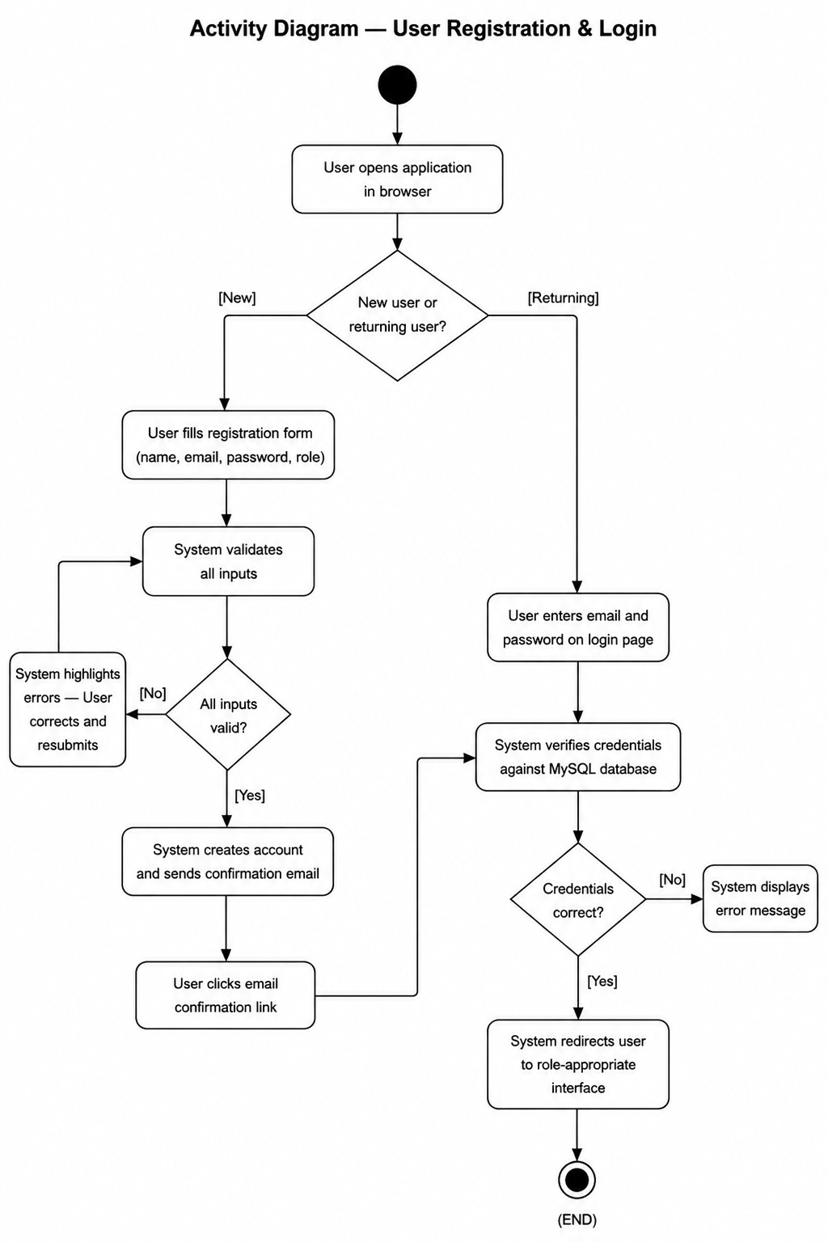

3.2. Use Case 2 — Assign Coding Task

ID | UC002
Name | Assign Coding Task
Description | Before any session can be measured, there needs to be a task for the developer to work on. This use case is how the administrator sets up tasks and hands them out to specific developers.
Requirement(s) | FR002
Actor(s) | System Administrator
Precondition | The administrator is logged in with admin privileges. There is at least one active developer account in the system.
Postcondition | The task is saved in the database and shows up in the developer's workspace. Each assigned developer gets a notification.
Basic Flow | Basic Flow  1. Administrator opens the Task Management panel.  2. Administrator clicks Create New Task.  3. Administrator fills in the task title, description, difficulty, time limit, and language.  4. Administrator picks which developer(s) to assign it to.  5. Administrator clicks Save and Assign.  6. System checks that all required fields are filled in.  7. System saves the task to MySQL and notifies the assigned developers.  Alternative Flow  1. Administrator copies an existing task, changes a few things, and assigns it to a different group of developers.  Exceptions  1. A required field is empty — System stops saving and highlights the missing field.  2. A chosen developer account has been deactivated — System warns the administrator about this.

Diagrams
The activity diagram below shows the step-by-step flow for Assign Coding Task (UC002).
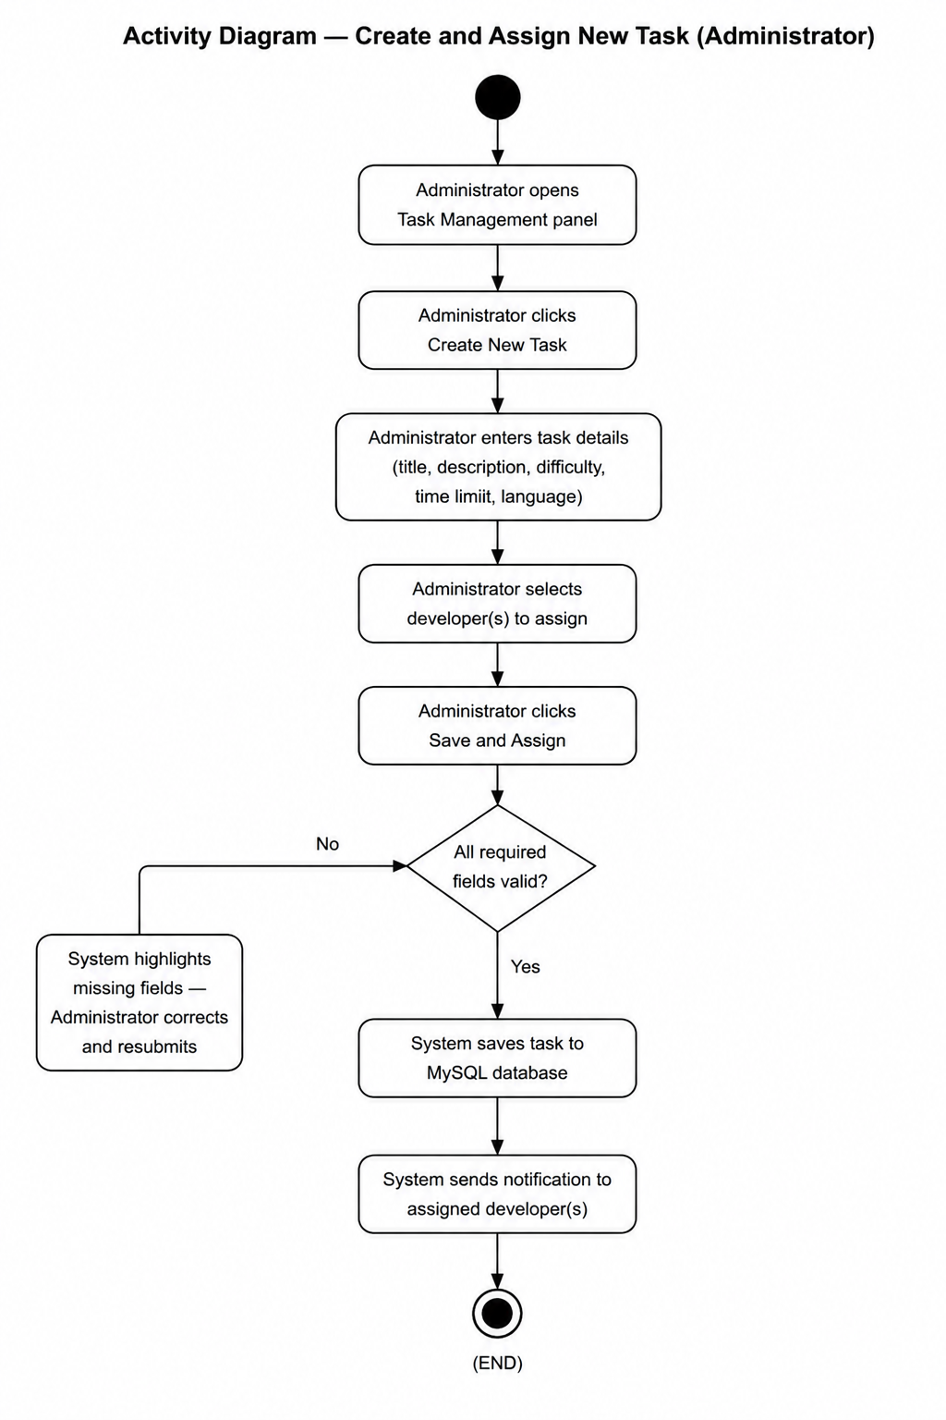

3.3. Use Case 3 — Conduct AI-Assisted Coding Session

ID | UC003
Name | Conduct AI-Assisted Coding Session
Description | This is the main use case of the whole system. It covers everything from the moment a developer opens a task to the moment they submit their answer, including any time they use the AI assistant.
Requirement(s) | FR003, FR004
Actor(s) | Developer
Precondition | The developer is logged in and has at least one task waiting in their workspace queue.
Postcondition | The developer's code is submitted. Every interaction event from the session is saved to MySQL and passed to the analytics engine.
Basic Flow | Basic Flow  1. Developer picks a task from the queue.  2. System loads the task, starts the timer, and begins the session log.  3. Developer reads the task and starts writing code in the Monaco editor.  4. System records each edit the developer makes, with a timestamp.  5. Developer clicks Run Code.  6. System runs the code and logs the result along with any errors.  7. Developer types a question into the AI assistant panel.  8. System sends the question to the OpenAI API and shows the answer in the panel.  9. System logs the question text and the time it was sent and answered.  10. Developer keeps editing, using the AI response as a guide.  11. Developer clicks Submit Solution when they are happy with their answer.  12. System logs the submission time and triggers the analytics engine (UC004).  Alternative Flow  1. Developer never uses the AI assistant — the log shows zero prompts and the analytics engine marks this as a Low Dependency session.  Exceptions  1. Timer runs out — System auto-submits whatever code is in the editor and moves on to analysis.  2. OpenAI API does not respond — System shows a message saying the assistant is unavailable and logs a failed request.

Diagrams
The activity diagram below shows the step-by-step flow for an AI-Assisted Coding Session (UC003).
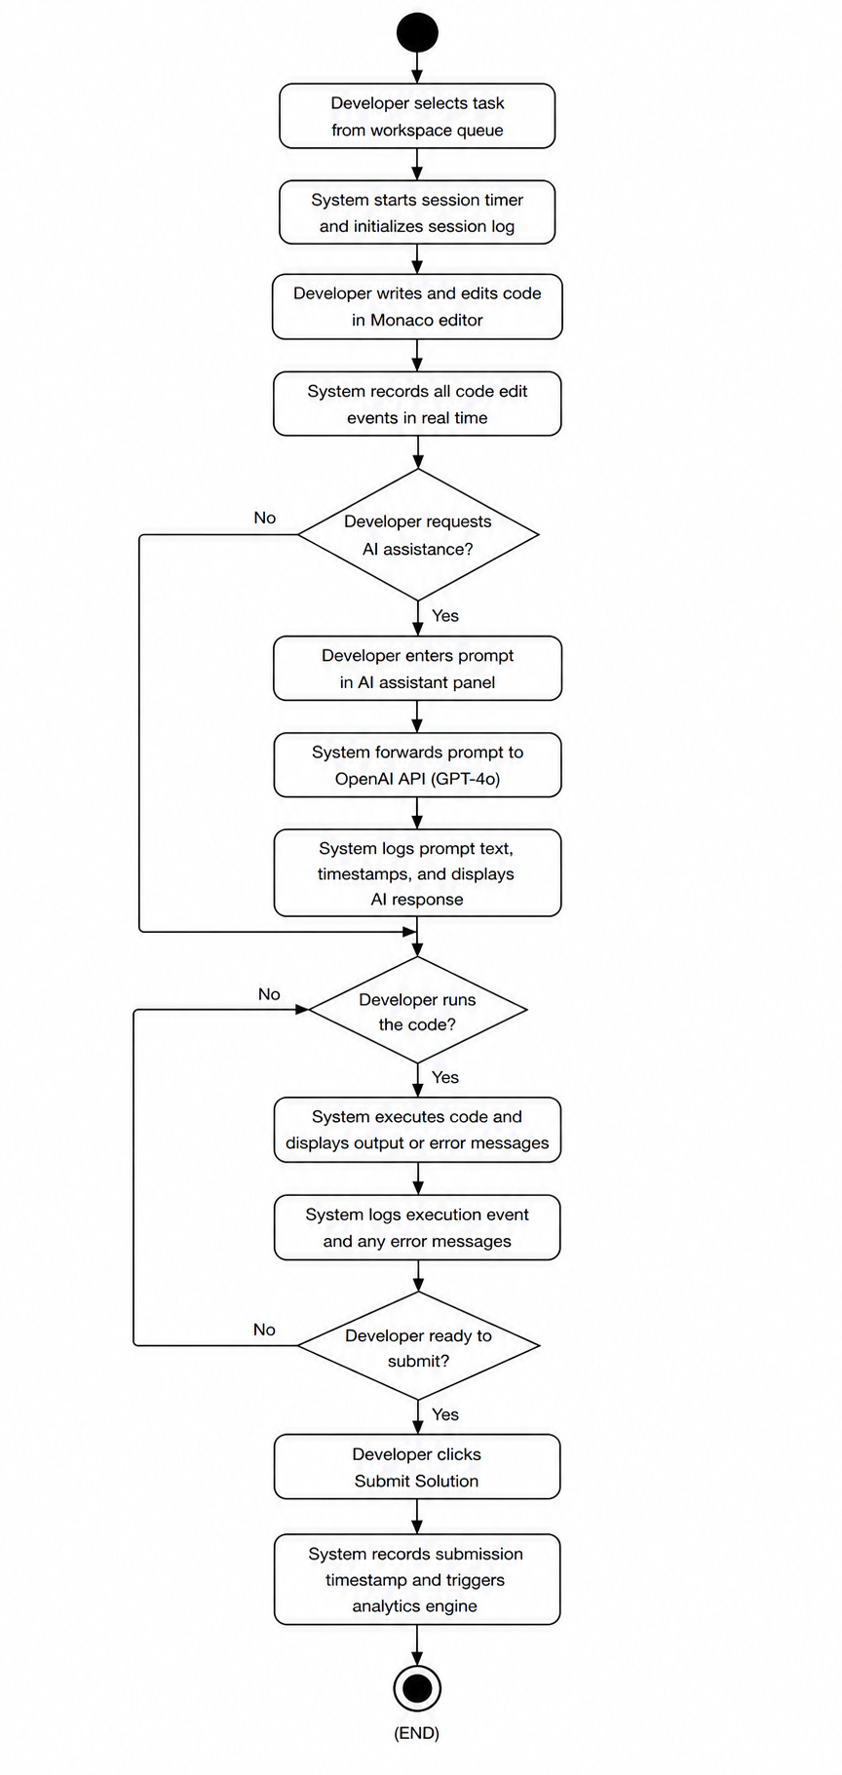

3.4. Use Case 4 — Analyse Session and Compute Performance Metrics

ID | UC004
Name | Analyse Session and Compute Performance Metrics
Description | After the developer submits their solution, the system takes over and analyses all the data that was collected. This use case is entirely automated — the developer does not do anything.
Requirement(s) | FR005
Actor(s) | System (automated)
Precondition | UC003 is finished. The session log and the submitted code are both in MySQL.
Postcondition | Performance Score, Productivity Score, Code Quality Score, AI Dependency Level, and an overall Efficiency Score are all calculated and saved. The dashboard is updated and the recommendation engine is triggered.
Basic Flow | Basic Flow  1. Analytics engine pulls the session log and submitted code from MySQL.  2. Engine works out the Performance Score based on how fast the task was finished vs. the time limit.  3. Engine works out the Productivity Score based on whether the code was correct and how much of it was meaningful.  4. Engine runs the code through the Code Quality Analyser to check for syntax errors, complexity, and readability.  5. Engine counts the total AI prompts and labels the session as Low (0-3), Medium (4-8), or High (9+) dependency.  6. Engine runs the formula: Efficiency Score = Performance(30%) + Productivity(30%) + Code Quality(20%) + AI Balance(20%).  7. Engine saves all the results to the session record in MySQL.  8. System triggers the dashboard update (UC005) and the recommendation engine (UC006).  Exceptions  1. Session log is incomplete because of a connection problem — engine marks the session as partial and calculates whatever it can.

Diagrams
The activity diagram below shows the step-by-step flow for session analysis and metric computation (UC004).
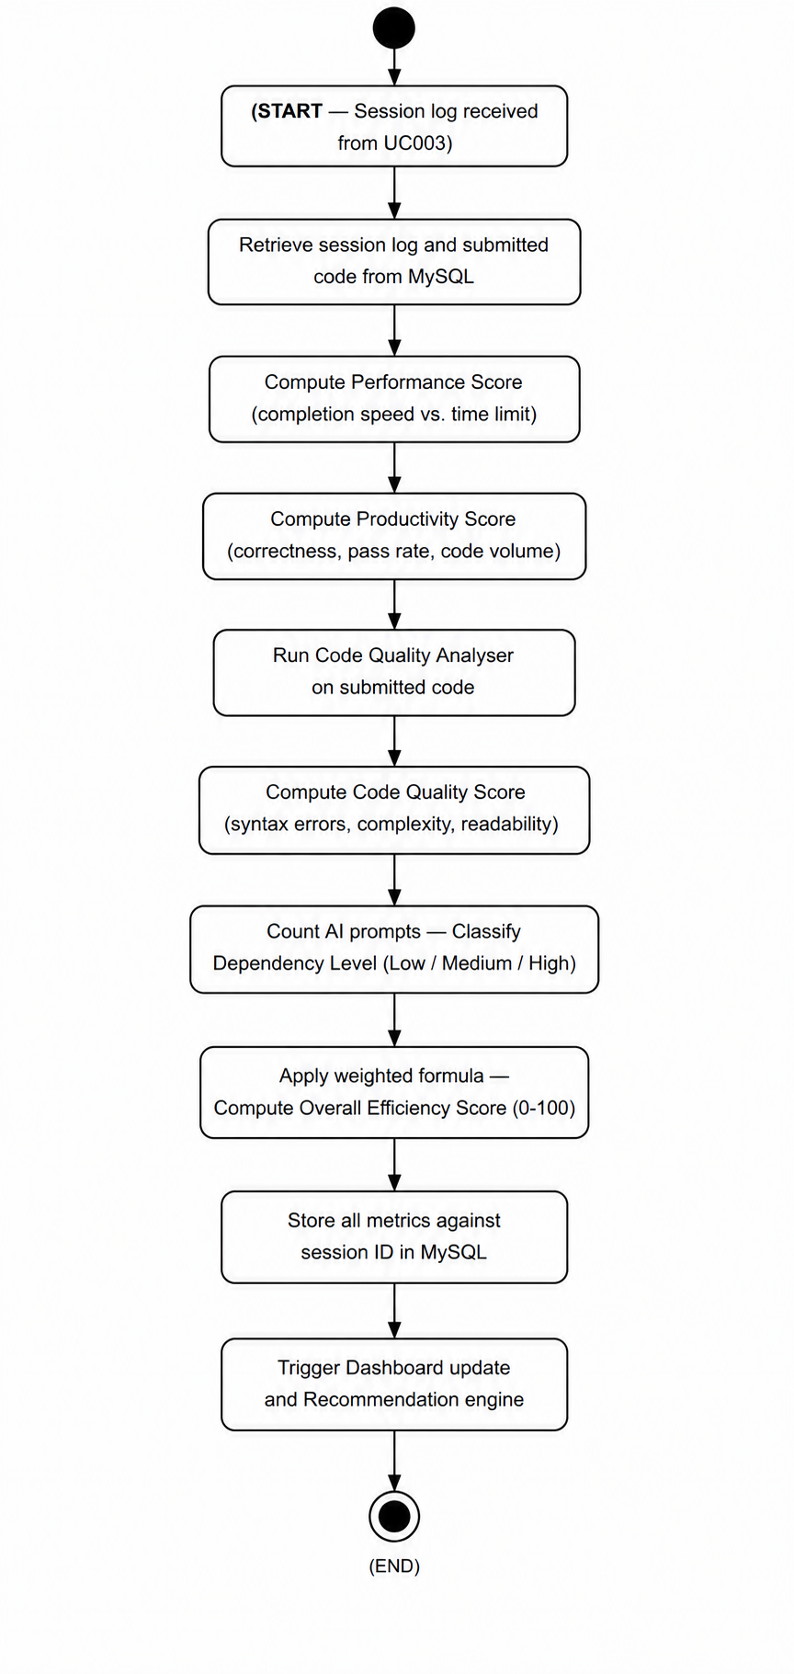

3.5. Use Case 5 — View Performance Metrics Dashboard

ID | UC005
Name | View Performance Metrics Dashboard
Description | This use case is how developers and team leads actually see the data that has been collected. The dashboard brings everything together in one place with charts and summaries.
Requirement(s) | FR006
Actor(s) | Developer, Team Lead
Precondition | The user is logged in and there is at least one completed and analysed session on their account.
Postcondition | The user can see an interactive dashboard with all their session data displayed in the time range they selected.
Basic Flow | Basic Flow  1. User clicks Dashboard in the navigation bar.  2. System fetches the session data from MySQL and shows the default view covering the last 30 days.  3. User looks at the Efficiency Score chart, AI Dependency bar chart, and Code Quality trend.  4. User sets a custom date range — System reloads all charts for that period.  5. User clicks Export Report — System creates and downloads a PDF summary.  Alternative Flow  1. A Team Lead picks a specific developer from the dropdown and sees that person's stats.  Exceptions  1. No sessions found for the selected date range — System shows: No data available for the selected period.

Diagrams
The activity diagram below shows the step-by-step flow for viewing the Performance Metrics Dashboard (UC005).

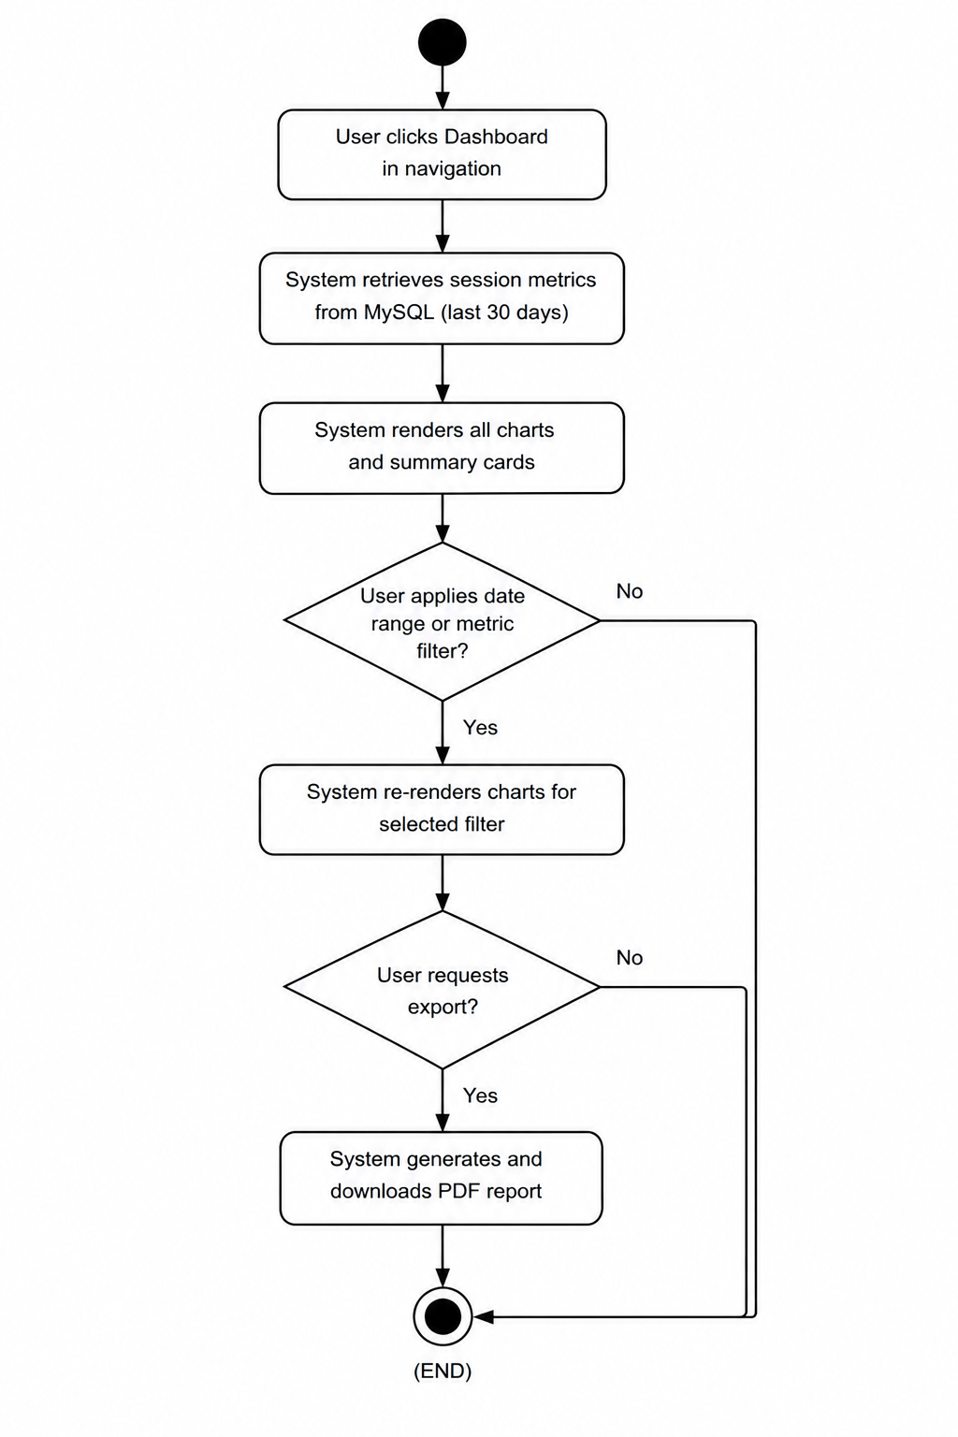

3.6. Use Case 6 — Receive Insights and Recommendations

ID | UC006
Name | Receive Insights and Recommendations
Description | Once a session is analysed, the developer gets a small set of specific feedback points — not just a score, but actual advice they can act on.
Requirement(s) | FR007
Actor(s) | Developer
Precondition | UC004 has finished running and the session metrics are in the database.
Postcondition | The developer sees three to five short feedback items on the post-session screen.
Basic Flow | Basic Flow  1. Recommendation engine retrieves the current session metrics and the developer's past averages from MySQL.  2. Engine compares each score to the developer's average and to the system's benchmark values.  3. Engine picks the three to five areas that would make the biggest difference.  4. Engine writes a short, plain sentence of feedback for each one.  5. System displays them on the post-session screen in order from most to least important.  6. Developer reads through them and can click View Full Dashboard if they want more detail.  Alternative Flow  1. Developer has fewer than 3 completed sessions — Engine shows general tips instead of personalized comparisons.  Exceptions  1. Metrics for this session are not available — System shows: Insight generation is currently unavailable.

Diagrams
The activity diagram below shows the step-by-step flow for generating insights and recommendations (UC006).

( START — triggered by UC004 finishing )
|
v
[ Fetch current session metrics and developer's historical averages from MySQL ]
|
v
[ Compare each metric to the personal average and system benchmark ]
|
v
[ Rank improvement areas by how much impact they would have ]
|
v
[ Write 3 to 5 short, plain-language feedback sentences ]
|
v
[ Show them on the post-session screen, most important first ]
|
v
[ Developer reads the feedback ]
|
v
( END )

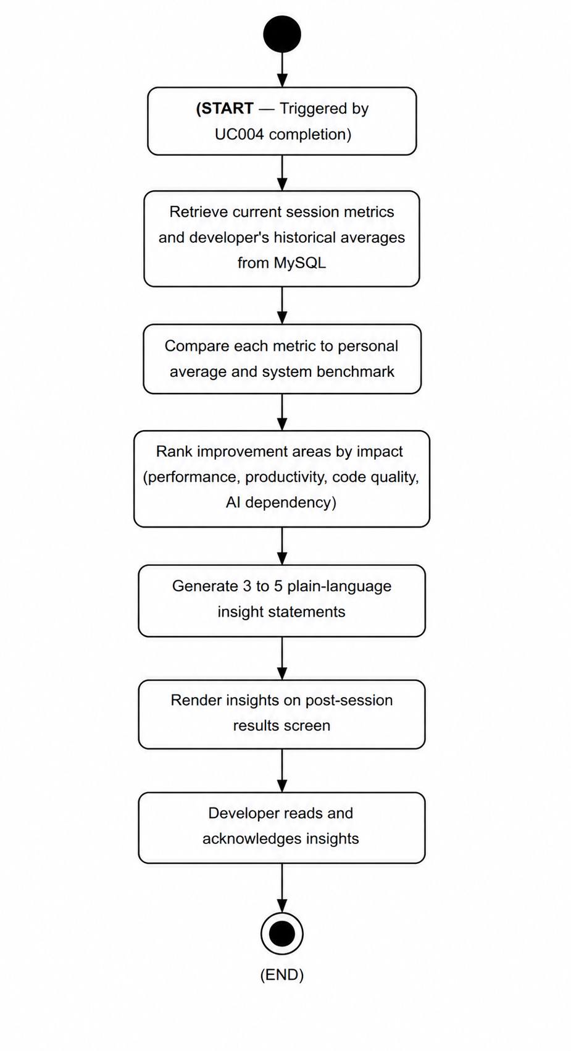

3.7. Use Case 7 — Receive Adaptive AI Assistance

ID | UC007
Name | Receive Adaptive AI Assistance
Description | Every time a developer sends a question to the AI assistant, the system adjusts how much help the AI gives based on the developer's skill level. This is meant to push better developers to think more independently.
Requirement(s) | FR008
Actor(s) | Developer, System
Pre-condition | The developer is in the middle of a session and has sent a question to the AI panel. The system already has a skill level classification for this developer based on their history.
Post-condition | The developer gets an AI response that is pitched at the right level for their skill. The interaction is logged.
Basic Flow | Basic Flow  1. Developer types a question into the AI assistant panel.  2. System checks the developer's current skill level — Beginner, Intermediate, or Expert.  3. System adds a short instruction at the start of the API request:  Beginner: Explain step by step with full code examples and explanations.  Intermediate: Give a conceptual hint only. Do not write the solution code.  Expert: Give one directional sentence. Encourage independent problem solving.  4. OpenAI API returns a response shaped by that instruction.  5. System shows the response in the AI panel.  6. System logs the prompt, the skill level that was used, and the response timestamp.  Alternative Flow  1. Developer manually sets their skill level for this session — System uses that override for the rest of the session.  Exceptions  1. No skill level can be determined (brand new user) — System defaults to Intermediate.

Diagrams
The activity diagram below shows the step-by-step flow for Adaptive AI Assistance (UC007).

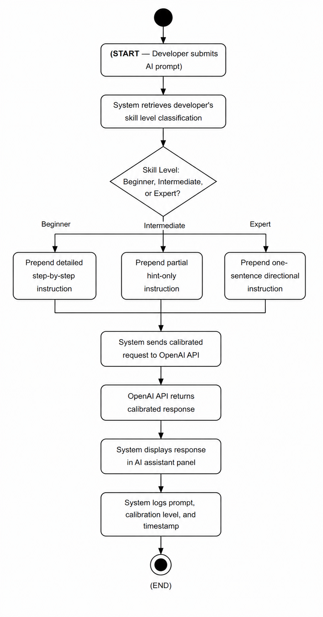

3.8. Use Case 8 — Track Skill Development

ID | UC008
Name | Track Skill Development
Description | Over time, a developer should be getting better. This use case is about showing that progress in a way that is easy to see, covering how their coding speed, error rate, AI usage, and code quality have changed across all their sessions.
Requirement(s) | FR009
Actor(s) | Developer, Team Lead
Precondition | The developer is logged in and has completed at least 3 sessions that have been analysed.
Postcondition | The Skill Development panel shows trend lines and an overall Skill Growth Index.
Basic Flow | Basic Flow  1. Developer opens the Skill Development panel from the dashboard.  2. System retrieves all past session metrics for that developer from MySQL.  3. System calculates the trend for each metric — coding speed, error count, AI dependency, and code quality.  4. System draws four trend charts and shows an overall Skill Growth Index card.  5. Developer looks through the trends and sees where they have improved and where they still need work.  Alternative Flow  1. A Team Lead opens the same panel for one of their developers to review progress.  Exceptions  1. Fewer than 3 sessions — System shows: Complete at least 3 sessions to unlock your Skill Development report.

Diagrams
The activity diagram below shows the step-by-step flow for Skill Development Tracking (UC008).

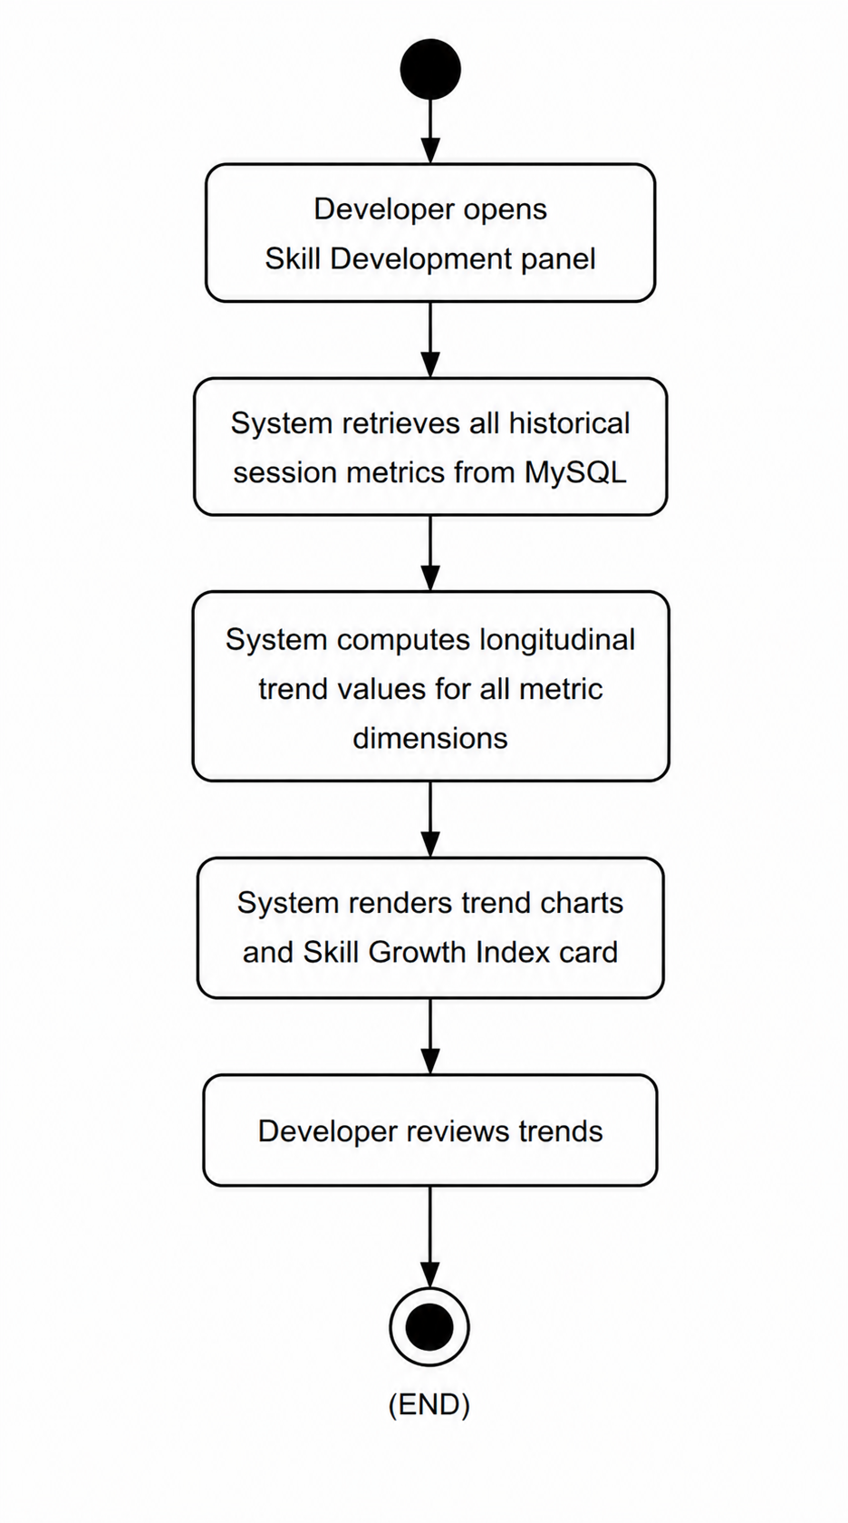

3.9. Use Case 9 — Manage System Administration Panel

ID | UC009
Name | Manage System Administration Panel
Description | The administrator needs a dedicated panel to keep the platform running — managing who has access, what tasks are available, and how the system is being used overall.
Requirement(s) | FR010
Actor(s) | System Administrator
Precondition | The administrator has logged in and opened the admin panel.
Postcondition | Whatever action the administrator took — editing a user, saving a task, or generating a report — is completed and the system reflects the change immediately.
Basic Flow | Basic Flow — User Management  1. Administrator opens the Users section.  2. Administrator filters the list by role or by active/inactive status.  3. Administrator selects a user and either changes their role, resets their password, or deactivates their account.  4. System applies the change and logs the action.  Basic Flow — Task Management  1. Administrator opens the Tasks section.  2. Administrator creates a new task or edits an existing one.  3. Administrator assigns it to selected developers and clicks Save.  4. System saves the task and notifies the assigned developers.  Basic Flow — Platform Report  1. Administrator clicks Generate Platform Report.  2. System pulls together total sessions, average Efficiency Score, and AI Dependency breakdown.  3. System shows the report and offers a PDF download.  Exceptions  1. Administrator tries to delete a user who still has active sessions — System blocks the deletion and says the account must be deactivated first.

Diagrams
The activity diagram below shows the step-by-step flow for System Administration (UC009).

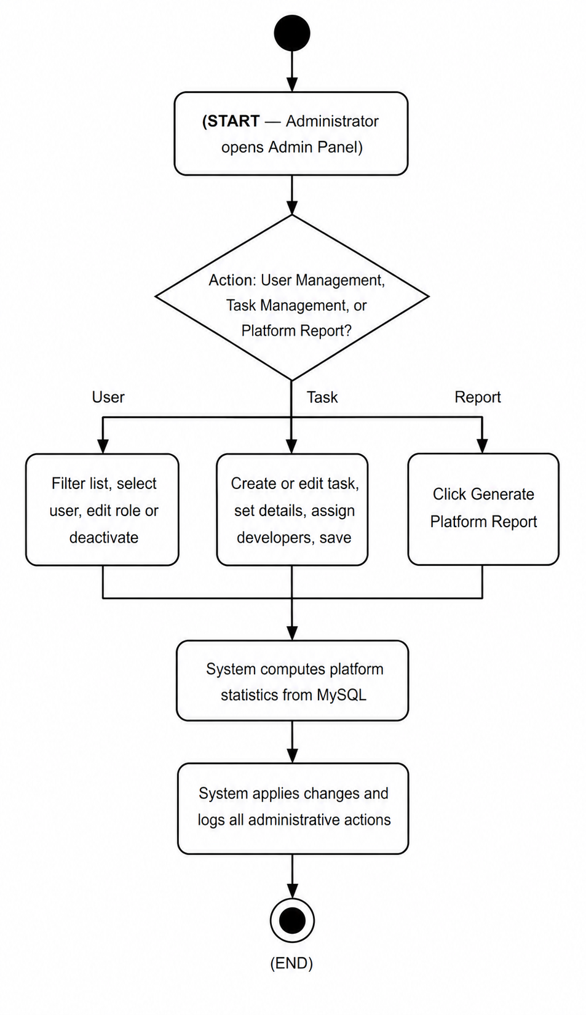

4. References
[1] P. Vaithilingam, T. Zhang, and E. L. Glassman, "Expectation vs. Experience: Evaluating the Usability of Code Generation Tools Powered by Large Language Models," in Extended Abstracts of the 2022 CHI Conference on Human Factors in Computing Systems, ACM, 2022.

[2] A. Ziegler et al., "Measuring GitHub Copilot's Impact on Productivity," Communications of the ACM, vol. 67, no. 3, pp. 54-63, 2024.

[3] GitHub, Inc., "GitHub Copilot — Your AI pair programmer," [Online]. Available: https://github.com/features/copilot

[4] OpenAI, "OpenAI API Documentation," 2024. [Online]. Available: https://platform.openai.com/docs

[5] Laravel LLC, "Laravel — The PHP Framework for Web Artisans," 2024. [Online]. Available: https://laravel.com

[6] Meta Open Source, "React — A JavaScript library for building user interfaces," 2024. [Online]. Available: https://react.dev

[7] Microsoft Corporation, "Monaco Editor," GitHub Repository, 2023. [Online]. Available: https://github.com/microsoft/monaco-editor

[8] M. A. Siddiqui and R. Ahmed, "Measuring Developer Productivity in AI-Augmented Environments," IEEE Transactions on Software Engineering, vol. 49, no. 4, pp. 1823-1840, 2023.

[9] Oracle Corporation, "MySQL 8.0 Reference Manual," 2024. [Online]. Available: https://dev.mysql.com/doc

